# Parallel Resistor Networks

## Objective

The focus of this exercise is an examination of basic parallel DC circuits with resistors. A key element is Kirchhoff’s Current Law which states that the sum of currents entering a node must equal the sum of the currents exiting that node. The current divider rule will also be investigated.

## Theory Overview

A parallel circuit is defined by the fact that all components share two common nodes. The voltage is the same across all components and will equal the applied source voltage. The total supplied current may be found by dividing the voltage source by the equivalent parallel resistance. It may also be found by summing the currents in all of the branches. The current through any resistor branch may be found by dividing the source voltage by the resistor value. Consequently, the currents in a parallel circuit are inversely proportional to the associated resistances. An alternate technique to find a particular current is the current divider rule. For a two resistor circuit this states that the current through one resistor is equal to the total current times the ratio of the other resistor to the total resistance.

## Schematics

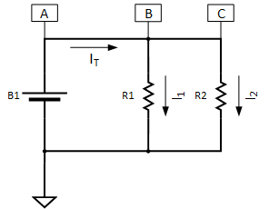

Figure 1 - Parallel Resistor Network

## Procedure

1. Given the circuit shown in Figure 1, determine the equivalent resistance of the circuit for and values given in Table 1 below. (Note that for the case where is a thermistor, you will need to measure the resistance under the conditions given in the table.)
2. Given , determine the voltages at points A, B and C with respect to ground:
3. Given the equivalent resistance found in A and using Ohm’s law (), determine the theoretical total current (), the current through () and the current through (). Record the values in Table 1 below.
4. Construct the resistor network on a breadboard. **Do not connect the battery at this point!** **Before** connecting the battery, measure the value of each resistor and the equivalent resistance. Record the equivalent resistance value in Table 1 and compare it to the theoretical value determined in step A.
5. Connect the battery and multimeter to measure the voltages at points A, B and C with respect to ground. (Note that the black lead of the multimeter should be connected to the ground reference point and the red lead should be connected to points A, B and C respectively.) Record the values below and compare to theoretical values in step B.
6. Using the multimeter, measure the total current (between points A and B), the current through (between point B and ), and the current through (between point C and ). (Note that current is measured at a single point in the circuit. The multimeter will need to be inserted between point B and , for example, to measure . The red lead of the multimeter should be connected to where the current is entering the meter and the black lead connected to the point where the current exiting. ) Record the values in Table 1 and compare them to the theoretical values determined in step C.

Table 1 - Calculated and Measured Circuit Values

|  |  |  |  |  |  |  |  |  |
| --- | --- | --- | --- | --- | --- | --- | --- | --- |
|  |  | **Calculated** | | | | **Measured** | | |
| **R1 ()** | **R2 ()** | **Req ()** | **IT (A) =**  **VB1 / Req** | **I1 (A)** | **I2 (A)** | **IT (A)** | **I1 (A)** | **I2 (A)** |
| 1K | 2K |  |  |  |  |  |  |  |
| 100K | Thermistor  Ambient Temp = |  |  |  |  |  |  |  |
| 100K | Thermistor  Iced = |  |  |  |  |  |  |  |

1. For extra credit, determine an equation for based on , and . (This is known as the ***current divider*** equation.)

We know that

*Eq. 1*

*Eq. 2*

Substituting Eq. 2 into Eq. 1, we have

*Eq. 3*

We also know that

*Eq. 4*

Therefore, substituting Eq. 4 for in Eq. 3, we have

*Eq. 5*

Or

1. Enter below circuit in LTSpice  
     
   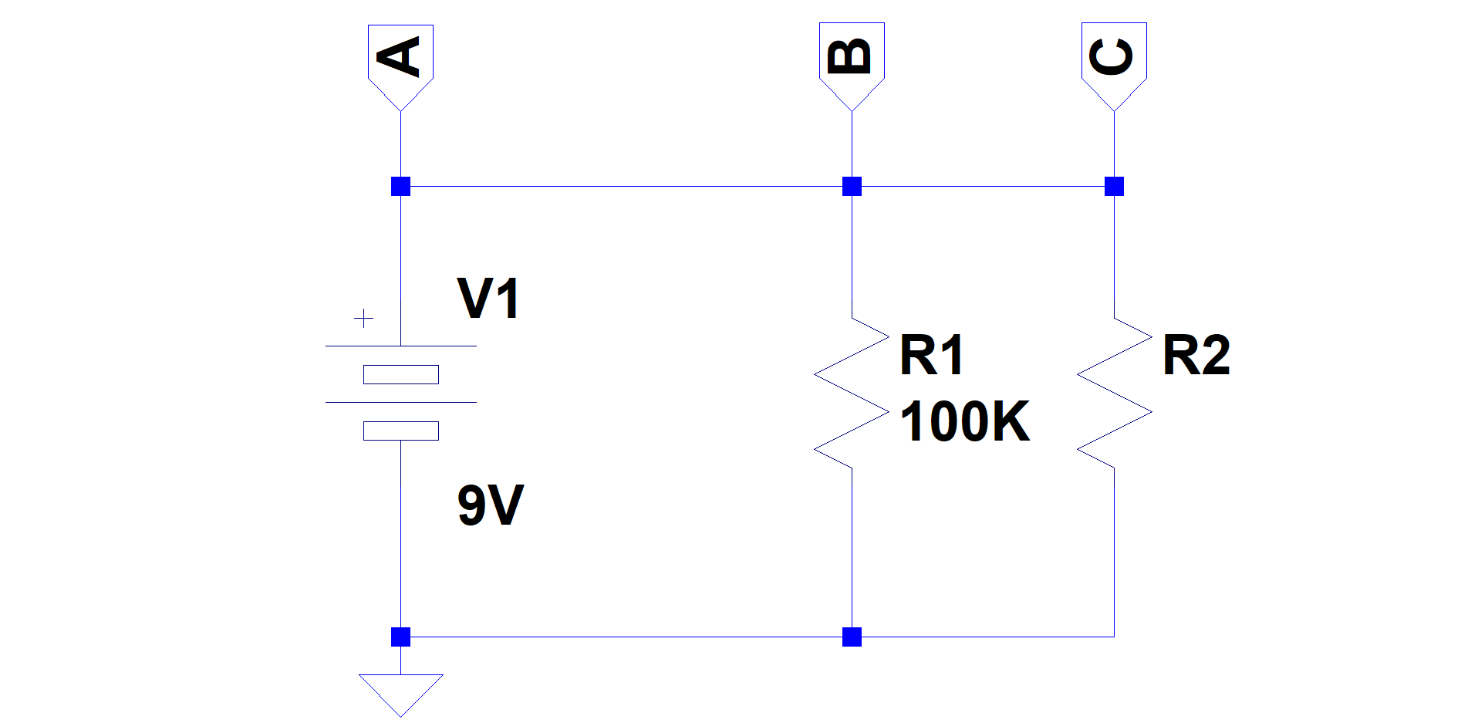  
   1. Make the value of R2 a parameter.
   2. Enter a SPICE directive to step the value of R2 from 80K to 480K in steps of 80K.
   3. Enter another SPICE directive to run a transient (time) simulation from 0 to 1ms stepping at 1us. The initial voltage value should be set to 0. (Recall that this was done by adding the “startup” parameter to the .tran SPICE directive.)
   4. Run the simulation, and record the values listed in Table 2 below for R2 = 80K and 480K.

Table 2 Parallel Resistor Network SPICE Simulation Results

|  |  |  |  |  |  |  |
| --- | --- | --- | --- | --- | --- | --- |
| **R2** | **VA (V)** | **VB (V)** | **VC (V)** | **IT (A)** | **I1 (A)** | **I2 (A)** |
| 80K |  |  |  |  |  |  |
| 480K |  |  |  |  |  |  |